**HOMEWORK**

**7th   GRADE OF PRIMARY SCHOOL**

|  |  |  |  |
| --- | --- | --- | --- |
| **Student Name** |  | | **Grade:** 7th grade |
| **Date:** Week 8 |
| **Unit: 1** | *“Feelings and Opinions”* | | |
| **O.A.(s):** | **OA 11** Demostrar comprensión de textos literarios al identificar: Palabras y frases clave, expresiones de uso frecuente, vocabulario temático. | | |
| **Objective** | To learn vocabulary related to hobbies and free time activities. | | |
| **Teacher:** | Constanza Caneo Zamora  **constanza.caneo@colegio-patriciomekis.cl** | **Subject:** | English |

1. **Look at the picture and write the correct name of each hobby. ( Mira las imágenes y escribe el nombre de cada hobby según corresponde)**

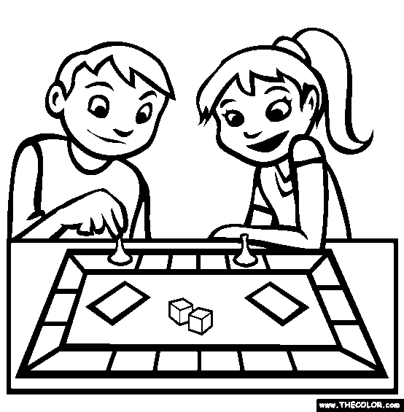

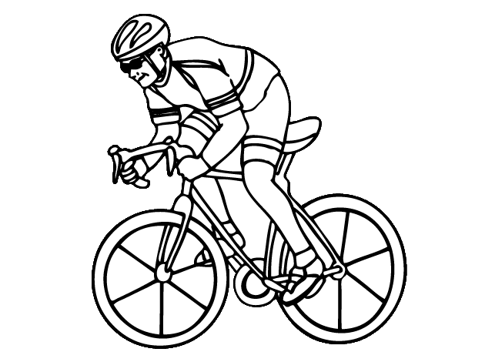

______________________ ___________________ __________________ ____________________

1. **Complete with the missing letter ( Completa con la letra que falta para formar la palabra o frase)**
2. **CYC__ING**
3. **SW__MM__NG**
4. **PL__Y B__AR__ G__MES**
5. **P__AY V__DE__ GAM__S**
6. **PA__NT__NG**
7. **W__TCH T__**
8. **L__ST__N TO M__SI__**