**ENGLISH WORKSHEET**

**6th   GRADE OF PRIMARY SCHOOL**

|  |  |  |  |
| --- | --- | --- | --- |
| **Student Name** |  | | **Grade:** 6th grade |
| **Date:** Week 8 |
| **Unit: 1** | *“Food and health”* | | |
| **O.A.(s):** | **OA 6** Leer comprensivamente textos no literarios, menús, recetas, para identificar vocabulario temático. | | |
| **Objective** | To distinguish food vocabulary in some texts. | | |
| **Teacher:** | Constanza Caneo Zamora  **constanza.caneo@colegio-patriciomekis.cl** | **Subject:** | English |

**VOCABULARY: identify, write, describe, demonstrate, select.**

1. **Look at these meals. Classify them into breakfast, lunch and dinner. (Lee las comidas que están dentro de las burbujas y selecciónalas si corresponde a desayuno, almuerzo o cena)**

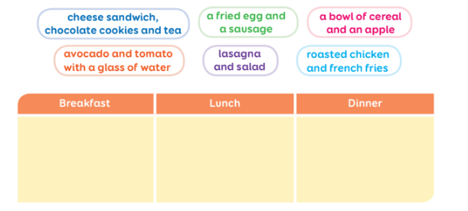

1. **Read the short paragraph and write in the chart all the ingredients that you find. (Lee el párrafo y escribe en la tabla todos los ingredientes que tú encuentres)**

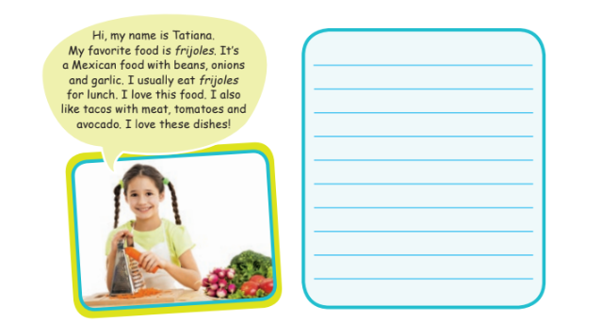

1. **Answer the following question ( Responde la siguiente pregunta)**

**What is your favorite food? (¿Cuál es tu comida favorita?)**

**___________________________________________________**

**___________________________________________________**

**___________________________________________________**